Lab Sheet 07

Question 01

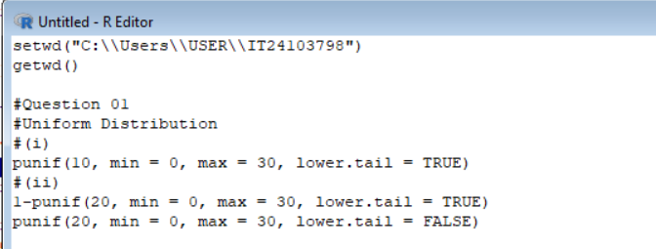

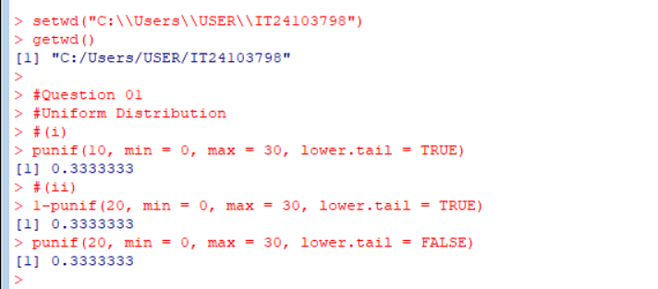

Question 02

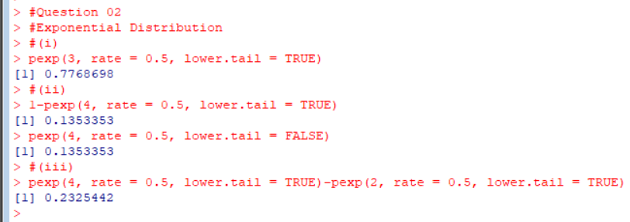

Question 03

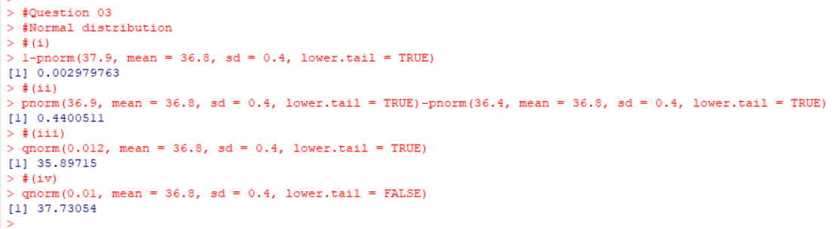

Exercise

Question 01

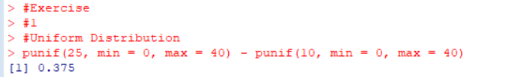

Question 02



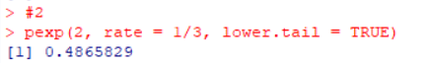

Question 03

